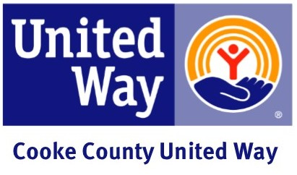

Results and Thanks Email
Subject: We Did It!

Dear (Employee Name),

We raised _____________ this year! I am extremely proud of you and the level of commitment shown by all of us at (business name). Thank you!

I am delighted that (company) is a part of the important work that United Way does to address what matters most to our community – helping our most vulnerable – helping our children achieve their potential, families become financially stable and everyone live healthy. You help build a better life for everyone.

Sincerely,

(CEO and/or Coordinator)

