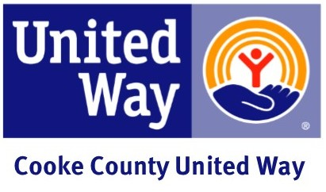

United Way Is and Does Email
Subject: UNITED WE FIGHT. UNITED WE WIN.

United Way envisions a world where all individuals and families achieve their human potential through education, financial stability and healthy lives. We win by forging unlikely partnerships. By finding new solutions to old problems. By mobilizing the best resources and by inspiring individuals to join the fight against their community’s most daunting social crises.

You have helped foster community-wide solutions including:

Helping children succeed Strengthening families Empowering healthy lives Comforting those in crisis

When you decide to fight for your community, it affects hundreds of thousands of lives in our area. Your support will make a significant difference in our community by improving the lives of our neighbors, families and friends.

Sincerely,

(CEO and/or Coordinator)

