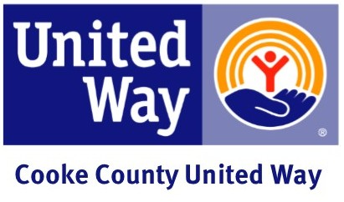

CEO Endorsement Letter 1
Dear (Employee's Name),
This year's United Way campaign will kick off at (Company's Name) on (Date), (Coordinator's Name or the Campaign Committee) has been chosen as our employee campaign coordinator and has added new and exciting dimensions to this year's drive. Cooke County United Way has always had the full support and commitment of (Company Name), and I am looking forward to this year's campaign with enthusiasm.
During the week of (Date), a meeting will be scheduled to better inform you of the services available through United Way agencies and to answer any questions you may have. I look forward to seeing you there. Thank you for helping (Company Name) Live United!
Sincerely,
(CEO / Manager)

