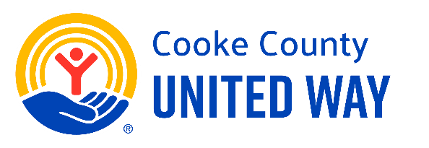

Day 1: How Cooke County United Way Impacts Our Community
Subject:
See the Difference We Can Make Together
Body:
Welcome to Day 1 of our 5 Days to Give United campaign!
This week, we’re joining with Cooke County United Way to make a real impact in our community. Through local partnerships and smart investments, United Way supports programs that:
- Help at-risk kids succeed in school
- Provide resources for financial stability
- Ensure access to mental and physical health care
- Support families during times of crisis
When you give to United Way, your support stays local - helping our neighbors, co-workers, and friends.
Stay tuned each day as we share more. Together, we can build a stronger, more connected community.
Learn More
Take 30 seconds to see how Cooke County United Way improves the academic achievement of at-risk children.

