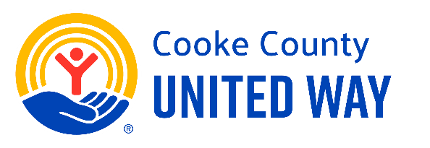

Day 2: Our Company’s Culture of Giving
Subject:
Giving Back is What We Do
Body:
Today is Day 2 of our 5 Days to Give United campaign!
Giving back has always been part of who we are. Over the years, our team has donated, volunteered, and come together to support those in need. It’s something that sets us apart - and something we can all be proud of.
Now, we have another chance to continue that legacy by supporting Cooke County United Way. Every dollar raised will directly support people in our area - helping children learn, families thrive, and individuals find hope.
Let’s continue showing our community what it means to be [COMPANY NAME] strong.
Learn More
Take 30 seconds to see how Cooke County United Way builds financial stability for people in our community.

