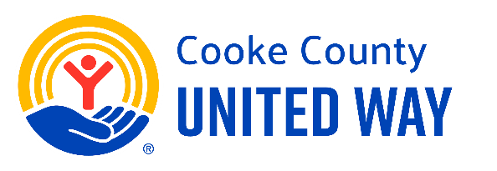

Day 5: It’s a Great Day to Give United!
Subject:
Today’s the Day - Let’s Give United! 💙
Body:
It’s Giving Day — the big finale to our 5 Days to Give United campaign!
Today, we come together as a team to support a cause that touches lives right here in our community. Whether you’ve already given or plan to today, THANK YOU for being part of something bigger.
Join us at the Giving Day Rally [insert time/place] for celebration, connection, and to make your gift.
Let’s finish strong and show what’s possible when we Give United!

