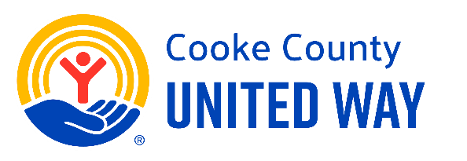

5 Days to Give United | Giving Rally Template

Sample Giving Rally Agenda
(Don’t forget the pens for signing the pledge forms!)
CEO and Campaign Coordinator open meeting and share about the impact of their business and why they support the mission of United Way.
Coordinator shares a personal story and/or one of the following speaks: Cooke County United Way rep
Partner agency rep or client speaks (optional)
United Way rep and Coordinator extend invitation to give and ask for employees’ support.
Coordinator collects pledge cards and thanks employees. Optional prize drawings.
Group picture for social media

